**Neural Networks & Deep Learning**

**ICP-3**

Sreeja Reddy Konda

700756597

GitHub-

Video-

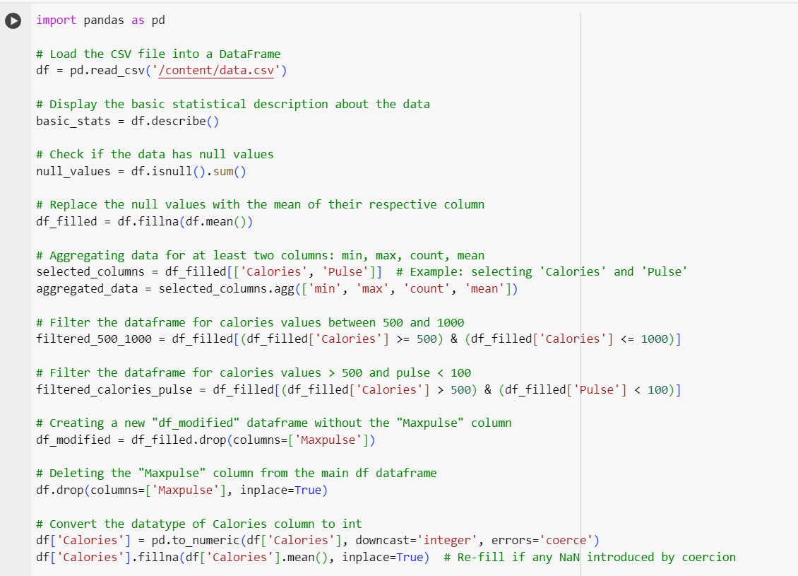

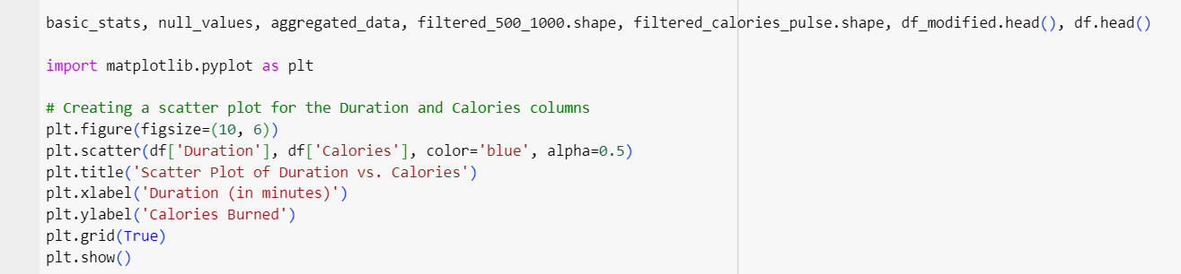

Output –

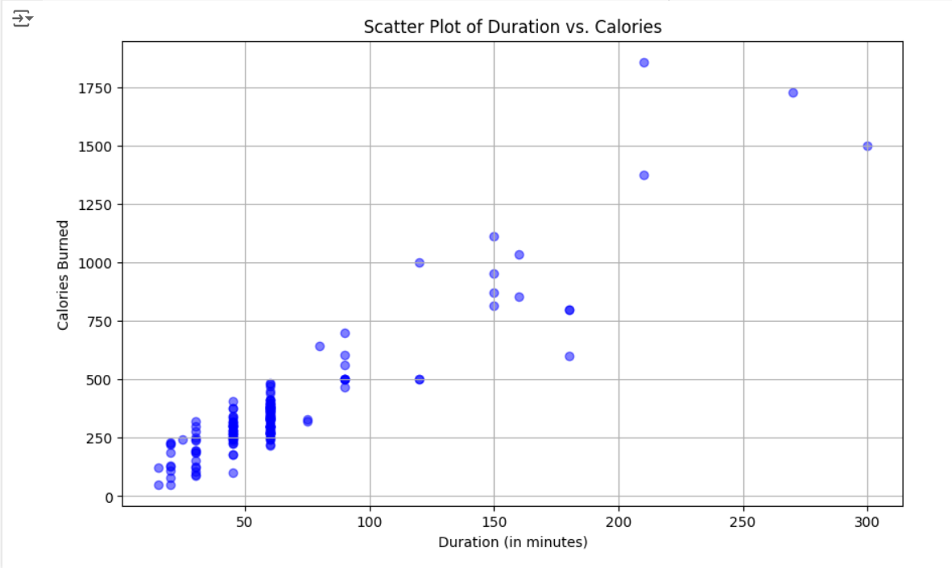

**Explanation**:

Loading file into a data frame. Then finding all the null values and filling them with mean value and using aggregate functions such as min, max, count, and mean for summarizing the data. Performing 2 filters on the data frame, one for “Calories“ in between 500 and 1000 other one is for “Calories” greater than 500 and “Pulse” less than 100. Dropping max pulse using df_filled.drop. At last convert the calories to integer so that later plotting can be done for duration vs calories.

2.

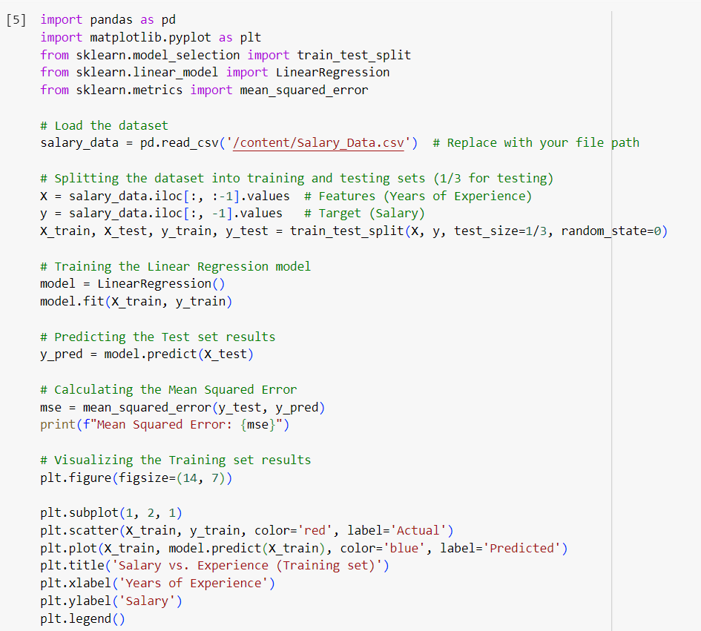

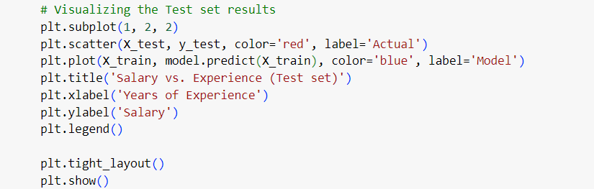

**Output:**

**Explanation:**

Loaded all data set and split all data into 2 sets representing training and testing sets. Training the linear regression model and predicting the test set results. Then calculating the MSE and visualizing the test set results and displaying the visualization using plt.tight_layout(), plt.show().